Measurement of endogenous acetone and isoprene in exhaled breath during sleep

Running head/short title: Breath acetone and isoprene during sleep

Julian King^{1,2,3}, Alexander Kupferthaler^{1,2}, Birgit Frauscher⁴, Heinz Hackner⁴, Karl Unterkofler^{1,5}, Gerald Teschl³, Hartmann Hinterhuber⁶, Anton Amann^{1,2,*}, Birgit Högl^{4,*}

¹ Breath Research Institute, Austrian Academy of Sciences, Rathausplatz 4, A-6850 Dornbirn, Austria
² Univ.-Clinic for Anesthesia, Innsbruck Medical University, Anichstr. 35, A-6020 Innsbruck, Austria
³ University of Vienna, Faculty of Mathematics, Nordbergstr. 15, A-1090 Vienna, Austria
⁴ Department of Neurology, Innsbruck Medical University, Anichstr. 35, A-6020 Innsbruck, Austria
⁵ Vorarlberg University of Applied Sciences, Hochschulstr. 1, A-6850 Dornbirn, Austria
⁶ Department of Psychiatry, Innsbruck Medical University, Anichstr. 35, A-6020 Innsbruck, Austria

* Shared corresponding authors:
Birgit Högl, Tel.: +43-512-504-23811, fax: +43-512-504-23842,
e-mail: birgit.ho@i-med.ac.at;
Anton Amann, Tel.: +43-676-5608520; fax: +43-512-504-6724636,
e-mail: anton.amann@i-med.ac.at

Work was performed at the Innsbruck Medical University. All authors have neither personal nor financial disclosures in the subject matter of the paper, nor are they involved with organizations with financial interest in the subject matter of the paper.

Abstract

This explorative study aims at characterizing the breath behavior of two prototypic volatile organic compounds (VOCs), acetone and isoprene, during normal human sleep and to possibly relate changes in the respective concentration time courses to the underlying sleep architecture. For this purpose, six normal healthy volunteers (2 female, 4 male, age 20-29 years) were monitored over two consecutive nights (the first one being an adaption night) by combining real-time proton-transfer-reaction mass spectrometry (PTR-MS) measurements from end-tidal exhalation segments with laboratory-based polysomnographic (PSG) data.
Breath acetone concentrations increased overnight in all measurements, with an average relative change by a factor of up to 4 (median 2.5). Nighttime concentration maxima were usually recorded 2-3 h before lights on.
For breath isoprene, a nocturnal increase in baseline concentrations of about 74% was observed, with individual changes ranging from 36-110%. Isoprene profiles exhibited pronounced concentration peaks, which were highly specific for leg movements as scored by tibial electromyography. Furthermore, relative to a linear trend, baseline isoprene concentrations decreased during the transition from the NREM to the REM phase of a complete sleep cycle.

Keywords:
exhaled breath analysis, volatile organic compounds, normal human sleep, acetone, isoprene

Abbreviations:
EEG Electroencephalography
EMG Electromyography
EOG Electrooculography
GC-MS Gas Chromatography Mass Spectrometry
ICG Impedance Cardiography
PSG Polysomnography
PSQI Pittsburg Sleep Quality Index
PTR-MS Proton Transfer Reaction Mass Spectrometry
SIFT-MS Selected Ion Flow Tube Mass Spectrometry
TFM Task Force Monitor
VOC Volatile Organic Compound

Introduction
In the past decades much progress has been made with respect to deepening the understanding of sleep-related physiology. Within this context, a particular focus has been given to the study of ventilatory, cardiovascular, and endocrine factors, as well as to the identification of regulatory processes affecting these systems during distinct states of sleep and wakefulness. Knowledge of these relationships is of crucial importance, particularly due to the fact that abnormal interactions between vital functions and their underlying control mechanisms are well known to be the source of clinically relevant pathologies that might manifest themselves over the entire sleep-wake cycle.
Recent progress in breath gas research suggests that endogenous volatile organic compounds (VOCs) contained in exhaled breath can provide insights into the physiological state of sleeping individuals which are complementary to those obtained by means of the conventional methodological approaches indicated above. The detection and quantification of these trace gases are accessible to non-invasive investigation and have been put forward as a potentially versatile tool for medical diagnosis (Risby et al., 1999, Schubert et al., 2003, Amann et al., 2004, Miekisch et al., 2004, Schubert et al., 2005, Gustafsson, 2005, Wehinger et al., 2007, Amann et al., 2007, Kushch et al., 2008, Bajtarevic et al., 2009, Amann et al., 2010, Filipiak et al., 2010, Amann et al., 2011) and assessments of body burden in response to medication and environmental exposure (Rieder et al., 2001, Erhart et al., 2009, Pleil, 2008, Pleil et al., 2000). As a particular advantage, exhaled breath can nowadays be measured at breath-by-breath resolution and in real-time (using, e.g., proton transfer reaction mass spectrometry (PTR-MS) (Lindinger et al., 1998, Herbig et al., 2009, Schwarz et al., 2009) or selected flow tube ion mass spectrometry (SIFT-MS) (Diskin et al., 2003)). Such real-time measurements allow for the continuous extraction of physiological/metabolic information on the test subject under scrutiny. Due to the direct influence which specific biochemical pathways may exert on sleep patterns (Tafti et al., 2003, Obal and Krueger, 2003), we expect that such information will also contribute to further elucidating the metabolic component of sleep in general.
So far, very little is known about sleep-related variations of VOC levels in exhaled breath. While earlier studies have attempted to monitor specific VOC profiles overnight, the results remain doubtful due to the fact that the test subjects had to be woken up in order to provide a breath sample (Cailleux and Allain, 1989). This can be a source of substantial measurement artifacts due to the drastic variations in ventilation and perfusion during the awakening phase (Karl et al., 2001). Consequently, an experimental regime allowing for uninterrupted sleep and parallel assessments of blood and respiratory flow appears mandatory for arriving at reliable data. A preliminary PTR-MS setup designed for this purpose has been described by our group (Amann et al., 2004, Amann et al., 2005, Amann et al., 2007). In this setup, however, only mixed expired rather than end-tidal air was collected and a simultaneous measurement of ventilation and cardiac output was not performed.
The present work is intended as a pilot study devoted to the investigation of end-tidal concentration profiles of two prototypic VOCs, isoprene and acetone, during normal sleep. More specifically, the primary objectives are to describe the long-term exhaled breath dynamics of these two trace gases and to possibly relate changes in the respective concentration time courses to the underlying sleep architecture.
Isoprene and acetone represent paradigmatic test compounds for a number of reasons. Both are primarily endogenous in origin and highly abundant in normal human breath, they have contrasting physical-chemical properties (isoprene is strongly lipophilic with low blood solubility, whereas acetone is hydrophilic and highly blood soluble) and both are reliably quantifiable by virtue of several distinct analytical techniques like PTR-MS (Kushch et al., 2008, Schwarz et al., 2009), SIFT-MS and GC-MS (Mendis et al., 1994). Furthermore, from the diurnal patterns of exhaled isoprene and the close links between acetone metabolism and lipolysis sleep-related modulations in breath output may be expected for both compounds (Cailleux and Allain, 1989, DeMaster and Nagasawa, 1978, Kalapos, 2003). In particular, the present study is also anticipated to provide reference datasets for future examinations of VOC profiles during sleep, potentially involving a wider range of VOCs (e.g., by using techniques largely obviating trade-offs between mass resolution and sampling frequency such as PTR-Time-of-Flight Mass Spectrometry, PTR-TOF (Herbig et al., 2009)).

Methods
The study was approved by the Ethics Commission of Innsbruck Medical University and was carried out in conformity with the Declaration of Helsinki.

2.1. Experimental setup
Major parts of the setup have been adapted from a previous PTR-MS study centering on synchronized measurements of end-tidal isoprene and acetone as well as of a number of respiratory and hemodynamic parameters during moderate ergometer workload scenarios. Extensive details regarding the underlying PTR-MS settings, quantification and cross-validation of VOC profiles by means of independent GC-MS analyses are given elsewhere (King et al., 2009, King et al., 2010b, Schwarz et al., 2009). Briefly, the instrumentation comprises four central parts, cf. figure 1.

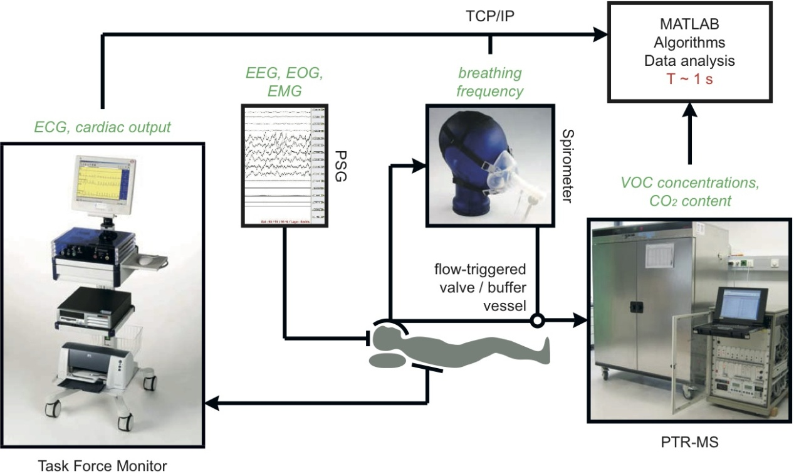

Figure 1: Overview of the complete study setup. Items in italic correspond to measured variables.

a) Polysomnography. PSG was performed by means of a Brainlab 4 system (Schwarzer, Munich, Germany). This device is widely used as a standard PSG monitoring solution and consists of an amplifier and a filter box connected via fiber optics to a PC running the Brainlab 4 software, version 4.0, patch pack 5. Within the PSG a 6-channel EEG with the following derivations was recorded: F3-M2, F4-M1, C3-M2, C4-M1, O1-M2, O2-M1. Four channels were used for the horizontal and vertical EOG recordings. EMG was applied to the mental, submental, and both anterior tibialis muscles. In addition, body position was recorded. Sleep stages were scored in 30 s periods according to standard AASM criteria (Iber et al., 2007) in the sleep laboratory of the Department of Neurology at Innsbruck Medical University by a trained polysomnographic technologist (HH). Leg movements (LM) were obtained by bilateral anterior tibialis EMG.
b) Respiratory monitoring. Respiratory flow was obtained by a SpiroStar USB differential pressure sensor (Medikro Oy, Kuopio, Finland). The test subject freely inhaled/exhaled through a flow transducer mouthpiece, which was connected to a silicone face mask covering mouth and nose (Hans Rudolph, Shawnee, USA). The pressure sensor then delivered volumetric flow rates within the flow transducer at a sampling frequency of 100 Hz. Algorithmic processing of this signal subsequently allowed for the calculation of breathing frequency. In principle, the above setup also permits a simultaneous determination of tidal volume, however, the high sensitivity of the flow rate scaling factor with respect to movement artifacts during sleep (e.g., lying on the pressure tube of the spirometer) in some cases prevented us from arriving at reliable volume time courses over the whole night.
c) Breath gas sampling and analysis. The face mask was heated to body temperature using an isolated heating wire (TNI Medical, Freiburg, Germany) and insulating tape in order to dispense heat uniformly. This was done to in order to prevent condensation of water vapor within the face mask. Condensed water droplets would attract hydrophilic VOCs, thereby depleting the sample and biasing the measurement results.
Exhaled breath samples were directed from the flow transducer to a high-sensitivity PTR-MS (Ionicon Analytik GmbH, Innsbruck, Austria) via a 5 m long, 1/4" Teflon sampling line, heated to a temperature of about 40°C in the same way as the face mask. A flow-triggered valve installed along this sampling line guaranteed that breath was only available for analysis in predefined (e.g., end-tidal) exhalation segments. Thus, an automatic real-time standardization of the breath extraction procedure could be achieved. Furthermore, in order to avoid PTR-MS drift chamber pressure fluctuations due to the deflation of the sampling line during longer valve closing times (corresponding to phases of uneven breathing, e.g., in apnea), a Teflon buffer vessel with a volume of about 10 ml was installed. This vessel also acts as a mechanical low-pass filter for the VOC concentrations delivered by PTR-MS, resulting in a slight smoothing of the associated signal.
End-tidal isoprene and acetone concentrations were determined in PTR-MS by monitoring their protonated forms at m/z = 69 (dwell time 200 ms) (Kushch et al., 2008) and m/z = 59 (dwell time 200 ms) (Schwarz et al., 2009), respectively. Additionally, for quantification purposes we routinely measure the mass-to-charge ratios m/z = 21 (isotopologue of the primary hydronium ions used for normalization; dwell time 500 ms), m/z = 37 (first monohydrate cluster for estimating sample humidity; dwell time 2 ms) as well as the parasitic precursor ions NH₄⁺ and O₂⁺ (at m/z = 18 and m/z = 32, respectively, with dwell times of 10 ms each), thus resulting in a sampling time of about 1 s (King et al., 2009, King et al., 2010b, Schwarz et al., 2009). The carbon dioxide content of the breath sample was derived from a separate sensor (AirSense Model 400, Digital Control Systems, Portland, USA). Additionally, transcutaneous hemoglobin oxygen saturation (SaO₂) was recorded.
d) Hemodynamic monitoring. Hemodynamic monitoring with beat-to-beat resolution was accomplished by means of a Task Force Monitor (TFM) system (CNSystems, Graz, Austria), involving standard ECG leads and transthoracic impedance cardiography (ICG) for the non-invasive determination of ejection (stroke) volume. For the continuous recording of ECG, heart rate, and cardiac output the proprietary TFM software, version 2.2, was used.

2.2. Test subjects and protocol
For this study 6 volunteers, 4 male and 2 female between 20 and 29 years of age, agreed to spend two consecutive nights in the sleep laboratory. After informed consent had been obtained, all participants were examined clinically and were attested a good physical condition. Pittsburg Sleep Quality Index (PSQI) scores ranged from 1 to 6, cf. table 1. No test subject reported any prescribed medication or drug intake. Participants were mainly non-smokers, except volunteer six who reported smoking sporadically. Due to the negligible influence of age, BMI, and smoking status on the breath levels of acetone and isoprene in adults no explicit control with respect to these covariates was enforced (Kushch et al., 2008, Schwarz et al., 2009, Euler et al., 1996).
When spending the night in the sleep laboratory the participant had to arrive at 8 pm. Instrumentation started with a head measurement according to the international 10-20 system. After using abrasive peeling paste (Skin-Pure, Nihon Kohden, Tokyo, Japan) and surgical spirit for cleaning, gold electrodes were applied to the scalp. The electrodes were then covered with gauze and firmly fixed by blowing compressed air over them to stiffen the collodion. Electrodes for EOG, chin and tibial EMG were attached with self-adhesive fabric tape (Mefix, Mölnlycke Health Care, Vienna, Austria). All electrodes were injected with low impedance highly conductive gel (SignaGel, Parker Labs, Fairfield, USA).
Subsequently, the volunteer was set up with the TFM electrodes, five to obtain a four-channel ECG and three more for ICG. Following a final briefing, the face mask was fixed to the test subject’s head by means of a hair cap. Special care was taken in order to avoid any leakage or discomfort in breathing. After bio-calibration of the PSG equipment the test subject was contacted one last time and then left alone to sleep. Lights off was usually recorded between 10-11 pm. Lights on was recorded exactly 8 hours later, i.e., time in bed equaled 480 min for each volunteer.

Results

Since the first night in the sleep laboratory was primarily intended as an adaption night, the results given in the following exclusively refer to the second night of each volunteer. All hemodynamic, respiratory and concentration profiles were interpolated to a common timeframe with a sampling interval of 1 s and smoothed using a median filter with a window width of 30 s.

3.1. General sleep-related and physiological data
The experimental setup was well tolerated by all test subjects. Sleep efficiency (the ratio between total sleep time and time spent in bed) ranged from 77 to 95% (median 90%) and sleep stage distributions as obtained by PSG were comparable with the typical fractional shares corresponding to a 30-year old adult (Moser et al., 2009), see table 1. Sleep and REM latency varied from 3 to 57 min (median 9.5 min) and from 56 to 200 min (median 95 min), respectively.

Volunteer | 1 | 2 | 3 | 4 | 5 | 6
Gender | f | m | m | m | m | f
Age | 27 | 22 | 24 | 26 | 20 | 29
Sleep-related data
PSQI score | 3 | 1 | 3 | 6 | 5 | 4
Lights off | 11:40 pm | 10:07 pm | 10:08 pm | 10:38 pm | 10:34 pm | 10:22 pm
Lights on | 07:40 am | 06:07 am | 06:08 am | 06:38 am | 06:34 am | 06:22 am
Total sleep time [h:min] | 07:30 | 6:10 | 06:54 | 06:35 | 07:35 | 07:34
Sleep efficiency [%] | 94 | 77 | 86 | 82 | 95 | 95
N1 sleep [%] | 4.6 | 10.5 | 4.9 | 7.9 | 7.7 | 5.8
N2 sleep [%] | 56 | 28 | 52.5 | 47.3 | 53.4 | 55.4
N3 sleep [%] | 14 | 20.9 | 15.7 | 19.5 | 16.9 | 18.4
REM sleep [%] | 23.6 | 21.1 | 20.6 | 20.4 | 18.2 | 17.8
Sleep latency [min] | 8 | 4 | 38 | 57 | 3 | 11
REM latency [min] | 60 | 87 | 56 | 114 | 200 | 103
Respiratory data
Mean SaO₂ [percent] | 97.1 (0.4) | 95.8 (1.1) | 95.3 (0.9) | 96.4 (0.8) | 95.9 (1) | 95.9 (0.8)
Min SaO₂ [percent] | 95 | 92 | 92 | 94 | 93 | 95
End-tidal CO₂ NREM [percent] | 5.5 (0.1) | 5.9 (0.4) | 6 (0.2) | 6.1 (0.2) | 6.2 (0.3) | 4.9 (0.2)
End-tidal CO₂ REM [percent] | 5.5 (0.1) | 6.1 (0.2) | 6 (0.1) | 6.1 (0.1) | 6.2 (0.2) | 4.9 (0.2)
Frequency NREM [tides/min] | 11.2 (0.8) | 15.3 (2) | 12.4 (1.5) | 13.3 (1.1) | 12.7 (2.4) | 15.2 (0.9)
Frequency REM [tides/min] | 12.6 (1.9) | 16.0 (2.4) | 11.7 (1.5) | 13.6 (1.3) | 15.5 (2.7) | 17.5 (2.4)
Hemodynamic data
Cardiac output NREM [l/min] | 3.7 (0.3) | 5.0 (0.6) | 4.4 (0.5) | 4.1 (0.4) | 5.1 (0.7) | 5.5 (0.5)
Cardiac output REM [l/min] | 3.8 (0.3) | 5.0 (0.4) | 4.1 (0.4) | 4.2 (0.3) | 4.8 (0.3) | 5.6 (0.3)

Table 1: General sleep-related and physiological data corresponding to the second night of each volunteer. Respiratory and hemodynamic data are given as mean (std).

Hemodynamic and respiratory behavior closely followed the typical patterns for normal human sleep. Mean transcutaneous hemoglobin oxygen saturation (SaO₂) over a 30 s period showed little variation throughout the night and remained above 92% for all volunteers. Similarly, exhaled breath CO₂ content generally exhibited a very stable behavior and resembled normal end-tidal levels, thus reconfirming the capability of the sampling regime to selectively extract the last segment of exhaled breath. Values for breathing frequency and cardiac output were found to vary within the normal physiological ranges, indicating that the instrumentation did not induce drastic ventilatory and/or hemodynamic changes. While cardiac output remained relatively stable throughout all nights, breathing frequency showed a more segmented pattern, with highly regular breathing during NREM and an increased variability during REM sleep. Typical profiles associated with these quantities are displayed in figure 2.

3.2 Acetone
Due to excessive room air contamination (probably due to an extensive PTR-MS calibration procedure earlier on that day), the acetone profile corresponding to volunteer six had to be excluded from the following analysis. For the remaining data sets, background levels of acetone recorded while drawing room air through the breath sampling system just before lights off usually were around 10% of the mean acetone level throughout the measurement and never exceeded 25% of that value.
End-tidal acetone concentrations at the onset of sleep (C_{start}; calculated as the median concentration over the first connected 5 min interval consisting of NREM phases only) varied from 234 to 580 ppb (parts per billion). Concentrations at the end of sleep (C_{end}; corresponding to the median concentration over the last connected 5 min interval before lights on consisting of NREM phases only) ranged from 575 to 1460 ppb. Breath acetone concentrations increased overnight in all measurements with individual relative changes C_{end}/C_{start} ranging from 1.10 to 4.09 (median 2.52). For perspective, in the first night volunteer six also showed an increase in acetone concentrations from C_{start} = 324 ppb to C_{end} = 646 ppb. A detailed overview of the derived concentration levels is given in table 2.

Volunteer | 1 | 2 | 3 | 4 | 5 | 6
C_{start} [ppb] | 580 | 286 | 547 | 234 | 309 | ---
C_{max} [ppb] /  Sleep stage | 1529 / W | 1392 / N1 | 685 / N1 | 838 / REM | 716 / W | ---
Time C_{max} [h:min] | 0:10 | 2:17 | 1:44 | 1:50 | 2:35 | ---
C_{end} [ppb] | 1460 | 1169 | 602 | 750 | 575 | ---
C_{end}/C_{start} | 2.52 | 4.09 | 1.10 | 3.20 | 1.86 | ---
Table 2: Acetone characteristics for the study cohort under scrutiny. Concentrations refer to end-tidal levels. Time C_{max} denotes the time before lights on when C_{max} was recorded. Other abbreviations refer to quantities described in the text.

Breath acetone levels usually remained steady for up to 2 h of sleep and reached a nighttime maximum C_{max} within the last 2-3 h before lights on. Within the remaining sleep period breath acetone either stabilized at this level or dropped slightly. In particular, the nighttime maximum did not show an obvious correlation to sleep stage. A representative profile is shown in the second panel of figure 2, while the entire ensemble of individual acetone profiles is depicted in figure 3.

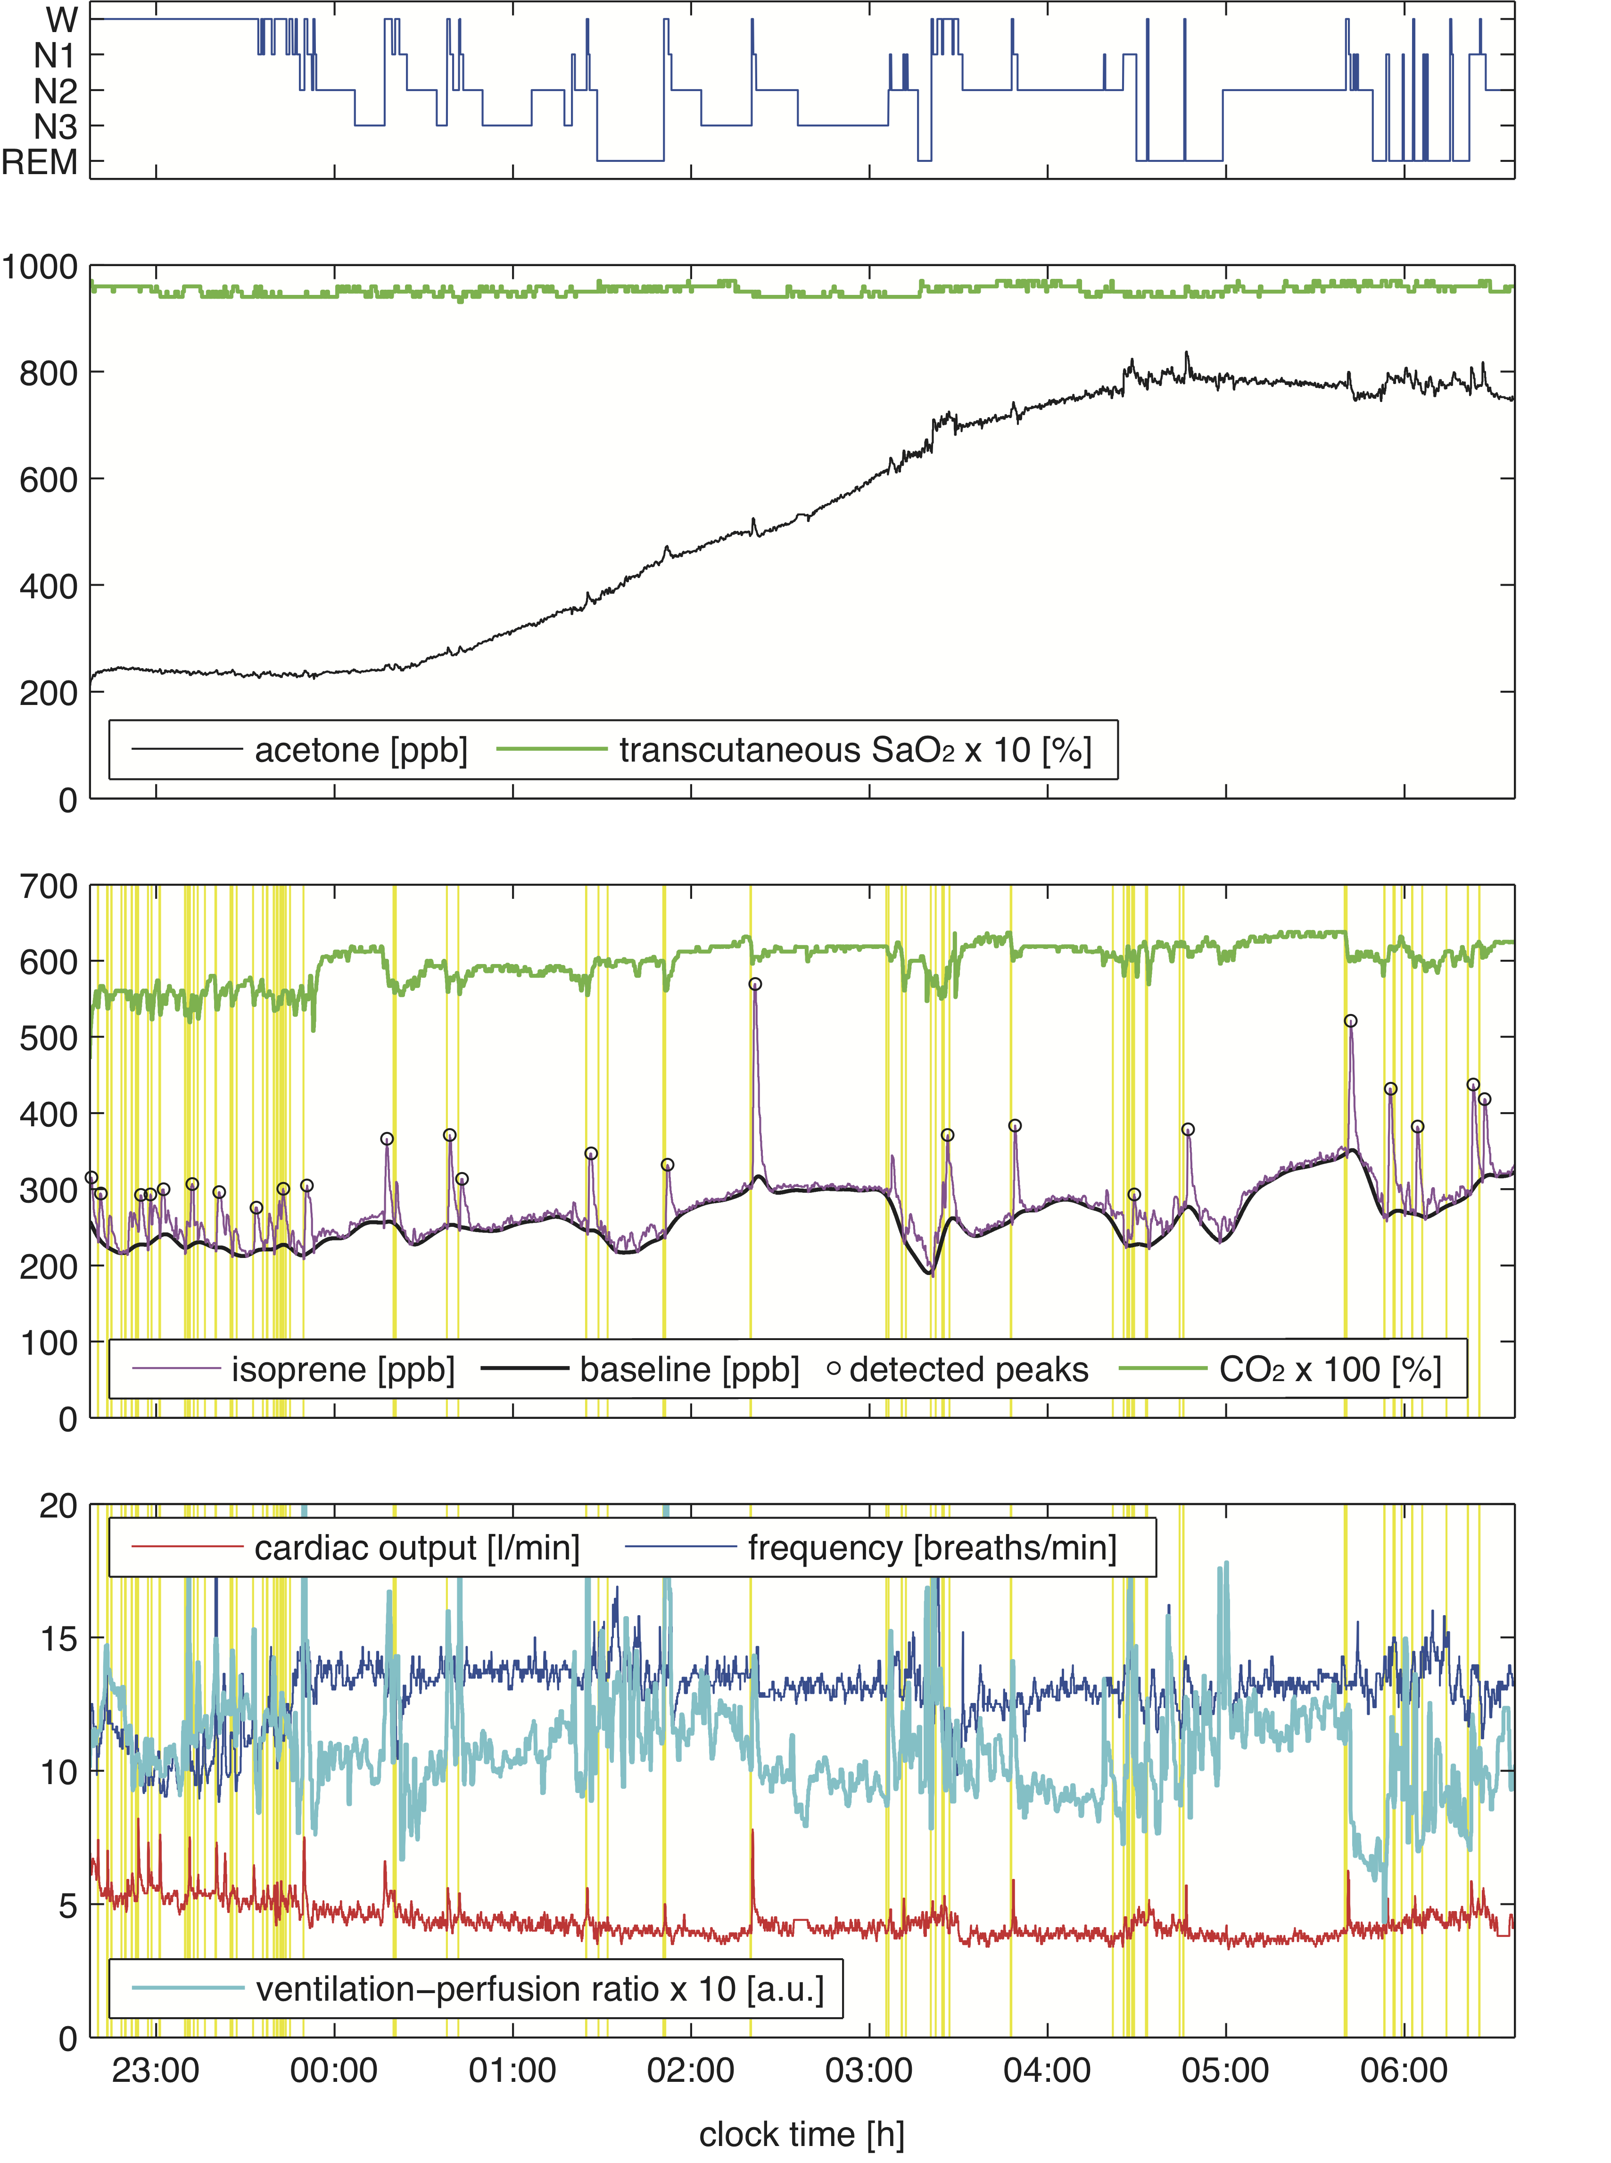
Figure 2: Representative measurements for a single test subject (volunteer four) over a full night. The associated hypnogram is given in the first panel. End-exhaled acetone and isoprene concentrations are presented in comparison with transcutaneous hemoglobin oxygen saturation (SaO₂) and end-exhaled CO₂ content. Major respiratory and hemodynamic variables are shown in panel four. An average ventilation-perfusion ratio was derived by multiplying breathing frequency and approximate tidal volume profiles and by dividing the result by the observed cardiac output. Additionally, a median filter with a window width of 60 s was applied for this signal. Note that isoprene peaks may arise in spite of increasing ventilation-perfusion ratios, which are expected to decrease VOC breath concentrations (as it is the case, e.g., for CO₂). Vertical lines in panel three and four depict leg movements as measured by anterior tibialis electromyography.

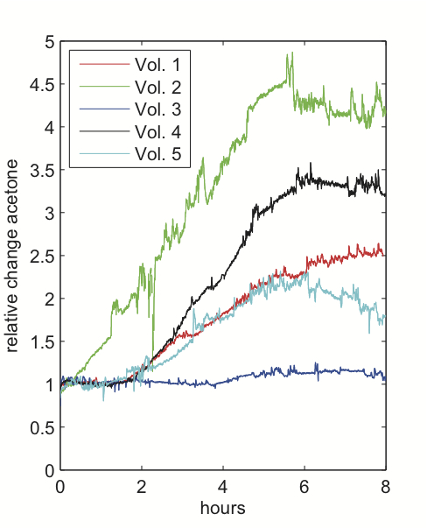
Figure 3: Relative changes in breath acetone between lights off and lights on for all volunteers described in table 2. Data were derived by normalizing the individual profiles with respect to the associated concentration C_{start} at the onset of sleep. The distorted signal for volunteer 2 around 2 h can be explained by a temporary drop in PTR-MS drift chamber pressure (probably resulting from erroneous valve control due to mask displacement, cf. section 2.1c)).

3.3. Isoprene
Background levels of isoprene were generally negligible, amounting to 2-6% of the mean value throughout the measurement.
In contrast to acetone, breath isoprene exhibited a high degree of short-term variability, showing characteristic concentration peaks throughout the night, cf. figure 2. These peaks correspond to an abrupt increase of 100 ppb and more within a few minutes, followed by a phase of gradual decline back to baseline levels. In order to analyze long- and short-term variability separately, we hence decomposed the isoprene profiles into two parts.

a) Baseline trend. Baseline estimation was achieved by subjecting the individual isoprene data to an asymmetric least squares smoothing algorithm (Eilers, 2004), yielding an isoprene baseline profile C_{b} with all peaks removed, cf. figure 2.
End-tidal breath isoprene concentration levels at the onset of sleep (C_{start}; calculated from C_{b} according to the same criteria as described in Section 3.2.) spread around a median value of 83 ppb (range 54-230 ppb). Isoprene concentrations at the end of sleep (C_{end}; calculated from C_{b} according to the same criteria as in Section 3.2.) showed typical values from 99 to 319 ppb. Baseline isoprene concentrations increased throughout the night in all measurements, the median of the individual relative changes C_{end}/C_{start} being 1.74 (range 1.36 to 2.10). A detailed overview of the derived concentration levels is given in table 3.

Volunteer | 1 | 2 | 3 | 4 | 5 | 6
C_{start} [ppb] | 58 | 54 | 149 | 230 | 101 | 65
C_{end} [ppb] | 122 | 99 | 250 | 319 | 137 | 117
C_{end}/C_{start} | 2.10 | 1.83 | 1.68 | 1.39 | 1.36 | 1.80
Peaks detected | 29 | 30 | 35 | 25 | 42 | 23
Peaks preceded by LM | 27 | 29 | 34 | 22 | 42 | 22
Peaks w/o shift in sleep stage | 4 | 0 | 4 | 1 | 3 | 3
Peaks w/o awakening | 11 | 1 | 7 | 3 | 21 | 12
Peaks in NREM | 18 | 9 | 22 | 8 | 35 | 14
Peaks in REM | 7 | 4 | 7 | 3 | 5 | 6
Table 3: Isoprene characteristics for the study cohort under scrutiny. Concentrations refer to end-tidal baseline levels. Abbreviations refer to quantities described in the text. Peaks without shift in sleep stage refer to isoprene peaks in N1, N2, N3, or REM, which are preceded by movement but are not accompanied by any shift in sleep stage within a 2 min interval before the peak maximum. Peaks without awakening refer to isoprene peaks in N1, N2, N3, or REM, which are preceded by movement but lack an associated awakening within a 2 min interval before the peak maximum.

Further information can be extracted from the baseline signal by considering its behavior within single sleep cycles. For this purpose, in each sleep cycle i we decomposed the baseline isoprene concentration C_{b} calculated above as C_{b} (t) = α_{i} + tβ_{i} + C_{res,i} (t) (i.e., we de-trended the baseline in each sleep cycle i by performing a standard linear regression with respect to time t, thereby yielding sleep cycle-dependent regression coefficients and residuals (α_{i} ,β_{i}) and C_{res,i}, respectively) and computed the normalized difference z_{i} = (C_{NREM.i} – C_{REM,i} )/C_{start} of the residual means C_{NREM,i} and C_{REM,i} in the NREM and REM phase of the sleep cycle, respectively. For the ease of understanding, a graphical illustration of this procedure is given in the third panel of figure 4. Iterating this step for the second night of each volunteer and employing a non-parametric sign test for statistical analysis, we found that z is different from zero with a median value of 0.1 (p < 0.01). In other words, relative to a linear trend, the baseline isoprene concentrations across all subjects decreased by about 10% of the individual C_{start} value during transitions from the NREM to the REM phase of a complete sleep cycle.

b) Peaks. In order to consistently identify concentration peaks within the individual isoprene concentration profiles we re-implemented a standard algorithm for detecting local extrema in physiological signals (Todd and Andrews, 1999). Here, a threshold value of δ = 0.25 C_{start} was used, i.e., a peak essentially corresponds to a signal deviation that locally “dominates” its surroundings by more than δ, cf. figure 2, third panel. Peaks appear in both NREM and REM sleep (with similar frequency when scaled to the duration of the respective sleep phase) and are highly specific for leg movements. More precisely, the chance that a detected peak is preceded by one or more scored leg movements falling within a 2 min interval before the peak maximum is over 90% in most individuals, cf. table 3. Additionally, after reviewing the polysomnographic data we found that those isoprene peaks not accounted for by leg movements occurred shortly after movement-related artifacts over the EEG channels, which are usually seen in case of large body movements. This observation indicates that movement is in fact a necessary condition for the appearance of breath isoprene peaks during sleep. Furthermore, it should be pointed out that while in many cases movements were closely tied to a shift in sleep stage or even an awakening, the latter events themselves do not appear sufficient for inducing an isoprene peak. Effectively, as shown in table 3 a number of peaks could be identified which were preceded by movement but lacked an associated shift in sleep stage or an awakening within a 2 min interval before the peak maximum.

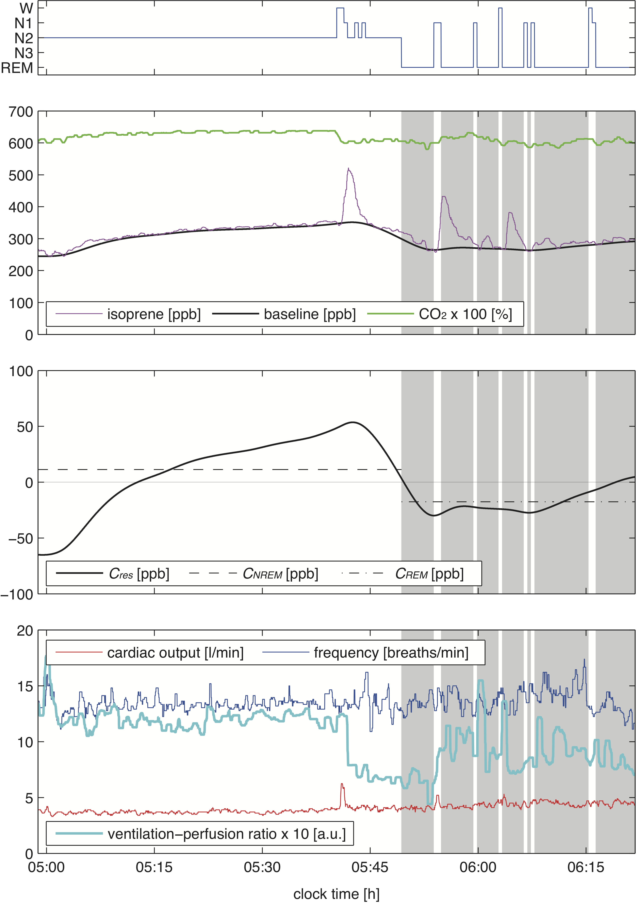
Figure 4: Isoprene characteristics during the last sleep cycle of volunteer four, cf. figure 2. REM segments are shaded in grey. The third panel shows the de-trended baseline signal C_{res} as well as the residual means C_{NREM} and C_{REM} in the NREM and REM phase of the sleep cycle, respectively (cf. Section 3.3.a)). Note that isoprene decreases during the transition from NREM to REM sleep, despite the fact that breathing frequency as well as cardiac output stays relatively constant.

Discussion
In this phenomenological study we intended to characterize the sleep-related behavior of two prototypic breath VOCs, acetone and isoprene, in a group of six normal healthy volunteers. Unlike end-tidal CO₂ content, which showed little variation, both compounds displayed characteristic dynamics during sleep, with steadily increasing breath concentrations in the case of acetone and isolated but pronounced concentration peaks throughout the night in the case of isoprene.
Breath acetone levels at the onset of sleep were directly comparable with daytime measurements of healthy adults, spreading around a concentration of 500 ppb (Schwarz et al., 2009). There was no obvious correspondence between acetone concentrations and specific events during sleep, although maximum values were usually recorded in sleep stages associated with more irregular breathing patterns (W, N1, and REM). This is in accordance with previous findings on highly soluble gas exchange during rest and exercise conditions, predicting that a major part of the breath-by-breath variability in acetone concentrations can be attributed to fluctuations in ventilatory flow (Anderson et al., 2006, King et al., 2011).
Biochemically, acetone represents a byproduct of fat catabolism (Kalapos, 2003). It hence seems natural to assume that the steady rise of breath acetone levels commonly observed during the sleep is a reflection of increased overnight lipolysis (Hagström-Toft et al., 1997). The onset of the latter has been reported to profoundly depend on the nocturnal release of growth hormone (Boyle et al., 1992), which is maximal during the first few hours of sleep (Moller et al., 1995, Van Cauter et al., 1997). Based on this rationale we see breath acetone measurements during sleep as an interesting tool for continuously monitoring the nocturnal interplay between hormonal secretory rhythm, carbohydrate metabolism and lipolysis/ketogenesis over longer periods of time (Spiegel et al., 2009, Leproult and Van Cauter, 2010). However, additional studies controlling dietary factors and including parallel measurements of blood glucose levels and endocrine function will be required for further strengthening the links outlined above. In addition, it has been demonstrated that fat content of the diet has an impact on circadian rhythmicity such as cycle length (Kohsaka et al., 2007). Furthermore, a genetic variant regulating CPT1B which is involved in fatty-acid β-oxydation has been linked to sleep regulation (Miyagawa et al., 2008).
Contrary to acetone, breath isoprene exhibits a high degree of short-term variability during sleep. Specifically, the frequently occurring concentration peaks throughout the night closely resemble the exhalation kinetics of this compound at the onset of exercise. It has been demonstrated in a number of studies that even moderate ergometer challenges with workload levels around 50 W are sufficient for increasing the end-tidal isoprene concentrations by a factor of ~ 3 to 4 within a delay time of 1-2 minutes after the start of pedaling, see, e.g., (Karl et al., 2001, King et al., 2009). In particular, these exercise-induced peaks emerge despite a parallel rise of the ventilation-perfusion ratio, which should lead to diminished breath concentrations of low blood soluble VOCs according to classical pulmonary inert gas elimination theory (Farhi, 1967). Similar observations can also be made during sleep, with isoprene peaks arising in spite of increasing ventilation-perfusion ratios, see figure 2.
In the case of exercise, this discrepancy has recently been explained by reference to an increased fractional perfusion of a peripheral isoprene buffer (probably representing skeletal muscle tissue) in response to physical activity (King et al., 2010a, Koc et al., 2011). The observation that a high percentage of breath isoprene peaks during sleep follow scored leg movements as determined by anterior tibialis electromyography (see table 3) appears to be consistent with this rationale. thus rendering breath isoprene as a potential complementary index for monitoring sleep behavior. In terms of sensitivity it should be noted, however, that not every EMG event implies the occurrence of an associated concentration peak. EMG events without isoprene increase are likely to correspond to movements of less intensity or with a smaller number of muscle groups involved, however, more precise assessments including accurate bio-calibration procedures and simultaneous video image recording will be required for corroborating this view.
At the onset of sleep, the individual isoprene levels in end-tidal breath for all test subjects conform to a concentration of about 100 ppb typical for adults under resting conditions (Kushch et al., 2008, King et al., 2009). In accordance with earlier findings, baseline isoprene concentrations tend to increase overnight (Cailleux and Allain, 1989, Amann et al., 2005, DeMaster and Nagasawa, 1978). The reason for this is still unclear. While ventilation and perfusion (cardiac output) have been demonstrated to constitute major physiological determinants of breath isoprene output (Karl et al., 2001, King et al., 2010a), the apparently stable behavior of the ventilation-perfusion ratio during periods of long-term isoprene increase (i.e., extending over 30 min and more, see figure 4 for instance) suggests that other factors such as changes in endogenous production and/or systemic distribution may have to be taken into account for clarifying this behavior. The primary source of isoprene formation in man has been attributed to the mevalonate pathway of cholesterol biosynthesis (Deneris et al., 1984), which indeed shows a circadian rhythm peaking during nighttime (Jones and Schoeller, 1990, Parker et al., 1982). However, whether this non-enzymatic pathway prevails in the endogenous production of isoprene under physiological conditions continues to be a matter of debate and the range of tissue groups contributing to the metabolic fate of isoprene remains to be settled.
It might be of interest in this context that the above-mentioned concentration increases appear to be associated mainly with the NREM phase of each sleep cycle, which is believed to be markedly anabolic in nature (Cardinali and Pandi-Perumal, 2006). In contrast, when entering the subsequent REM phase a more or less pronounced drop of the baseline isoprene level can be observed, cf. section 3.3a). Part of this concentration decrease seems to be attributable to a slight rise in ventilatory flow as reflected by the frequency data in table 1, leading to diminished alveolar concentrations of low blood soluble VOCs according to classical pulmonary inert gas elimination theory (Farhi, 1967). However, due to the inherent non-steady state behavior of breathing during REM, drawing definite conclusions is difficult in this context. Furthermore, by adopting the above-mentioned peripheral muscle source of isoprene as a working hypothesis, additional sleep stage specific factors such as muscle atonia or reduced muscle blood flow might play a role in the observed reduction of breath isoprene output during REM periods (Miki et al., 2004).

Conclusions
Exhaled breath analysis is becoming increasingly recognized as an intriguing tool for gaining non-invasive information on the current physiological state of an individual. Major advantages of this methodology when compared to conventional test procedures include unlimited sampling as well as the possibility for a real-time analysis of physiological/metabolic events. This is of particular interest in sleep research where the continuous extraction of other biochemical probes such as blood or urine samples is both cumbersome and time-intensive.
Within this context, we have described a setup for consistently measuring overnight concentration profiles of acetone and isoprene, two of the most abundant endogenous trace gases in human breath. With the advent of novel mass spectrometric techniques offering full spectral information in each measurement cycle (such as PTR-TOF (Herbig et al., 2009)) as well as compact substance-specific sensors drastically reducing instrumental burden we are confident that future investigations will rapidly extend this knowledge base and yield further insights into the links between breath VOCs and sleep-related physiology.

- Acknowledgements
The research leading to these results has received funding from the European Community’s Seventh Framework Programme (FP7/2007-13) under grant agreement No. 217967. We appreciate funding from the Austrian Federal Ministry for Transport, Innovation and Technology (BMVIT/BMWA, project 818803, KIRAS). Gerald Teschl and Julian King acknowledge support from the Austrian Science Fund (FWF) under Grant No. Y330. We greatly appreciate the generous support (unrestricted grant) by the government of Vorarlberg, Austria. Furthermore, we thank Peter Hamm, Helmut Wiesenhofer, and Maria Schmid for their excellent technical assistance.

- References
Amann, A., Corradi, M., Mazzone, P. & Mutti, A. (2011) Lung cancer biomarkers in exhaled breath. Expert Rev Mol Diagn, 11, 207-17.
Amann, A., Ligor, M., Ligor, T., Bajtarevic, A., Ager, C., Pienz, M., Denz, H., Fiegl, M., Hilbe, W., Weiss, W., Lukas, P., Jamnig, H., Hackl, M., Haidenberger, A., Sponring, A., Filipiak, W., Miekisch, W., Schubert, J. & Buszewski, B. (2010) Analysis of exhaled breath for screening of lung cancer patients. Magazine of European Medical Oncology, 3, 106 - 112.
Amann, A., Poupart, G., Telser, S., Ledochowski, M., Schmid, A. & Mechtcheriakov, S. (2004) Applications of breath gas analysis in medicine. Int J Mass Spectrometry, 239, 227 - 233.
Amann, A., Spanel, P. & Smith, D. (2007) Breath analysis: the approach towards clinical applications. Mini reviews in Medicinal Chemistry, 7, 115 - 129.
Amann, A., Telser, S., Hofer, L., Schmid, A. & Hinterhuber, H. (2005) Breath gas as a biochemical probe in sleeping individuals. Breath Analysis for Clinical Diagnosis and Therapeutic Monitoring. Singapore, World Scientific.
Anderson, J. C., Lamm, W. J. & Hlastala, M. P. (2006) Measuring airway exchange of endogenous acetone using a single-exhalation breathing maneuver. J. Appl. Physiol., 100, 880-9.
Bajtarevic, A., Ager, C., Pienz, M., Klieber, M., Schwarz, K., Ligor, M., Ligor, T., Filipiak, W., Denz, H., Fiegl, M., Hilbe, W., Weiss, W., Lukas, P., Jamnig, H., Hackl, M., Haidenberger, A., Buszewski, B., Miekisch, W., Schubert, J. & Amann, A. (2009) Noninvasive detection of lung cancer by analysis of exhaled breath. BMC Cancer, 9, 348.
Boyle, P. J., Avogaro, A., Smith, L., Bier, D. M., Pappu, A. S., Illingworth, D. R. & Cryer, P. E. (1992) Role of GH in regulating nocturnal rates of lipolysis and plasma mevalonate levels in normal and diabetic humans. Am J Physiol, 263, E168-72.
Cailleux, A. & Allain, P. (1989) Isoprene and sleep. Life Sci., 44, 1877-1880.
Cardinali, D. P. & Pandi-Perumal, S. R. (2006) Neuroendocrine correlates of sleep/wakefulness, New York, NY, Springer.
DeMaster, E. G. & Nagasawa, H. T. (1978) Isoprene, an endogenous constituent of human alveolar air with a diurnal pattern of excretion. Life Sci., 22, 91-7.
Deneris, E. S., Stein, R. A. & Mead, J. F. (1984) In vitro biosynthesis of isoprene from mevalonate utilizing a rat liver cytosolic fraction. Biochem. Biophys. Res. Commun., 123, 691-6.
Diskin, A. M., Spanel, P. & Smith, D. (2003) Time variation of ammonia, acetone, isoprene and ethanol in breath: a quantitative SIFT-MS study over 30 days. Physiol Meas, 24, 107-19.
Eilers, P. H. (2004) Parametric time warping. Anal. Chem., 76, 404-11.
Erhart, S., Amann, A., Karall, D., Edlinger, G., Haberlandt, E., Schmid, A., Filipiak, W., Mochalski, P., Rostasy, K. & Scholl-Bürgi, S. (2009) 3-Heptanone as a potential new marker for valproic acid therapy. J Breath Res, 3, 016004 (6 pp).
Euler, D. E., Dave, S. J. & Guo, H. (1996) Effect of cigarette smoking on pentane excretion in alveolar breath. Clinical chemistry, 42, 303-8.
Farhi, L. E. (1967) Elimination of inert gas by the lung. Respir. Physiol., 3, 1-11.
Filipiak, W., Sponring, A., Filipiak, A., Ager, C., Schubert, J., Miekisch, W., Amann, A. & Troppmair, J. (2010) TD-GC-MS analysis of volatile metabolites of human lung cancer and normal cells in vitro. Cancer Epidemiol Biomarkers Prev, 19, 182-95.
Gustafsson, L. (2005) Exhaled nitric oxide: how and why we know it is important. IN AMANN, A. & SMITH, D. (Eds.) Breath Analysis for Clinical Diagnosis and Therapeutic Monitoring. Singapore, World Scientific.
Hagström-Toft, E., Bolinder, J., Ungerstedt, U. & Arner, P. (1997) A circadian rhythm in lipid mobilization which is altered in IDDM. Diabetologia, 40, 1070-1078.
Herbig, J., Muller, M., Schallhart, S., Titzmann, T., Graus, M. & Hansel, A. (2009) On-line breath analysis with PTR-TOF. J. Breath Res., 3, 027004.
Iber, C., Ancoli-Israel, S., Chesson, A. & Quan, S. (2007) for the American Academy of Sleep Medicine. The AASM Manual for the Scoring of Sleep and Associated Events: Rules, Terminology and Technical Specifications. 1st ed., Westchester (Illinois), American Academy of Sleep Medicine.
Jones, P. J. H. & Schoeller, D. A. (1990) Evidence for diurnal periodicity in human cholesterol synthesis. J. Lipid Res., 31, 667-672.
Kalapos, M. P. (2003) On the mammalian acetone metabolism: from chemistry to clinical implications. Biochim. Biophys. Acta, 1621, 122-39.
Karl, T., Prazeller, P., Mayr, D., Jordan, A., Rieder, J., Fall, R. & Lindinger, W. (2001) Human breath isoprene and its relation to blood cholesterol levels: new measurements and modeling. J. Appl. Physiol., 91, 762-70.
King, J., Koc, H., Unterkofler, K., Mochalski, P., Kupferthaler, A., Teschl, G., Teschl, S., Hinterhuber, H. & Amann, A. (2010a) Physiological modeling of isoprene dynamics in exhaled breath. J. Theor. Biol., 267, 626-637.
King, J., Kupferthaler, A., Unterkofler, K., Koc, H., Teschl, S., Teschl, G., Miekisch, W., Schubert, J., Hinterhuber, H. & Amann, A. (2009) Isoprene and acetone concentration profiles during exercise on an ergometer. J. Breath Res., 3, 027006 (16pp).
King, J., Mochalski, P., Kupferthaler, A., Unterkofler, K., Koc, H., Filipiak, W., Teschl, S., Hinterhuber, H. & Amann, A. (2010b) Dynamic profiles of volatile organic compounds in exhaled breath as determined by a coupled PTR-MS/GC-MS study. Physiol. Meas., 31, 1169-1184.
King, J., Unterkofler, K., Teschl, G., Teschl, S., Koc, H., Hinterhuber, H. & Amann, A. (2011) A mathematical model for breath gas analysis of volatile organic compounds with special emphasis on acetone. J. Math. Biol., DOI 10.1007/s00285-010-0398-9.
Koc, H., King, J., Teschl, G., Unterkofler, K., Teschl, S., Mochalski, P., Hinterhuber, H. & Amann, A. (2011) The role of mathematical modeling in VOC analysis using isoprene as a prototypic example. J. Breath Res., 5, 037102.
Kohsaka, A., Laposky, A. D., Ramsey, K. M., Estrada, C., Joshu, C., Kobayashi, Y., Turek, F. W. & Bass, J. (2007) High-fat diet disrupts behavioral and molecular circadian rhythms in mice. Cell metabolism, 6, 414-21.
Kushch, I., Arendacka, B., Stolc, S., Mochalski, P., Filipiak, W., Schwarz, K., Schwentner, L., Schmid, A., Dzien, A., Lechleitner, M., Witkovsky, V., Miekisch, W., Schubert, J., Unterkofler, K. & Amann, A. (2008) Breath isoprene-aspects of normal physiology related to age, gender and cholesterol profile as determined in a proton transfer reaction mass spectrometry study. Clin. Chem. Lab. Med., 46, 1011-1018.
Leproult, R. & Van Cauter, E. (2010) Role of sleep and sleep loss in hormonal release and metabolism. Endocrine development, 17, 11-21.
Lindinger, W., Hansel, A. & Jordan, A. (1998) On-line monitoring of volatile organic compounds at pptv levels by means of proton-transfer-reaction mass spectrometry (PTR-MS) - Medical applications, food control and environmental research. Int. J. Mass Spectrometry, 173, 191-241.
Mendis, S., Sobotka, P. A. & Euler, D. E. (1994) Pentane and isoprene in expired air from humans: gas-chromatographic analysis of single breath. Clin Chem, 40, 1485-8.
Miekisch, W., Schubert, J. K. & Noeldge-Schomburg, G. F. (2004) Diagnostic potential of breath analysis--focus on volatile organic compounds. Clin Chim Acta, 347, 25-39.
Miki, K., Oda, M., Kamijyo, N., Kawahara, K. & Yoshimoto, M. (2004) Lumbar sympathetic nerve activity and hindquarter blood flow during REM sleep in rats. J. Physiol., 557, 261-71.
Miyagawa, T., Kawashima, M., Nishida, N., Ohashi, J., Kimura, R., Fujimoto, A., Shimada, M., Morishita, S., Shigeta, T., Lin, L., Hong, S. C., Faraco, J., Shin, Y. K., Jeong, J. H., Okazaki, Y., Tsuji, S., Honda, M., Honda, Y., Mignot, E. & Tokunaga, K. (2008) Variant between CPT1B and CHKB associated with susceptibility to narcolepsy. Nature genetics, 40, 1324-8.
Moller, N., Jorgensen, J. O., Moller, J., Orskov, L., Ovesen, P., Schmitz, O., Christiansen, J. S. & Orskov, H. (1995) Metabolic effects of growth hormone in humans. Metabolism, 44, 33-6.
Moser, D., Anderer, P., Gruber, G., Parapatics, S., Loretz, E., Boeck, M., Kloesch, G., Heller, E., Schmidt, A., Danker-Hopfe, H., Saletu, B., Zeitlhofer, J. & Dorffner, G. (2009) Sleep classification according to AASM and Rechtschaffen & Kales: effects on sleep scoring parameters. Sleep, 32, 139-49.
Obal, F., Jr. & Krueger, J. M. (2003) Biochemical regulation of non-rapid-eye-movement sleep. Front Biosci, 8, d520-50.
Parker, T. S., McNamara, D. J., Brown, C., Garrigan, O., Kolb, R., Batwin, H. & Ahrens, E. H., Jr. (1982) Mevalonic acid in human plasma: relationship of concentration and circadian rhythm to cholesterol synthesis rates in man. Proc. Natl. Acad. Sci. U. S. A., 79, 3037-41.
Pleil, J. D. (2008) Role of exhaled breath biomarkers in environmental health science. Journal of Toxicology and Environmental Health-Part B-Critical Reviews, 11, 613-629.
Pleil, J. D., Smith, L. B. & Zelnick, S. D. (2000) Personal exposure to JP-8 jet fuel vapors and exhaust at Air Force bases. Environmental Health Perspectives, 108, 183-192.
Rieder, J., Prazeller, P., Boehler, M., Lirk, P., Lindinger, W. & Amann, A. (2001) Online monitoring of air quality at the postanesthetic care unit by proton-transfer-reaction mass spectrometry. Anesth Analg, 92, 389-92.
Risby, T. H., Jiang, L., Stoll, S., Ingram, D., Spangler, E., Heim, J., Cutler, R., Roth, G. S. & Rifkind, J. M. (1999) Breath ethane as a marker of reactive oxygen species during manipulation of diet and oxygen tension in rats. J Appl Physiol, 86, 617-22.
Schubert, J., Miekisch, W. & Geiger, K. (2003) Exhaled breath markers in ARDS. IN MARCZIN, N. & KHARITONOV, S. (Eds.) Lung Biology in Health and Disease. Disease Markers in Exhaled Breath. New York, Marcel Dekker.
Schubert, J., Miekisch, W. & Nöldge-Schomburg, G. (2005) VOC breath markers in critically ill patients: potentials and limitations. IN AMANN, A. & SMITH, D. (Eds.) Breath Analysis for Clinical Diagnosis and Therapeutic Monitoring. Singapore, World Scientific.
Schwarz, K., Pizzini, A., Arendacka, B., Zerlauth, K., Filipiak, W., Schmid, A., Dzien, A., Neuner, S., Lechleitner, M., Scholl-Burgi, S., Miekisch, W., Schubert, J., Unterkofler, K., Witkovsky, V., Gastl, G. & Amann, A. (2009) Breath acetone - aspects of normal physiology related to age and gender as determined in a PTR-MS study. J. Breath Res., 3, 027003 (9pp).
Spiegel, K., Tasali, E., Leproult, R. & Van Cauter, E. (2009) Effects of poor and short sleep on glucose metabolism and obesity risk. Nature reviews. Endocrinology, 5, 253-61.
Tafti, M., Petit, B., Chollet, D., Neidhart, E., de Bilbao, F., Kiss, J. Z., Wood, P. A. & Franken, P. (2003) Deficiency in short-chain fatty acid beta-oxidation affects theta oscillations during sleep. Nat Genet, 34, 320-5.
Todd, B. S. & Andrews, D. C. (1999) The identification of peaks in physiological signals. Comput. Biomed. Res., 32, 322-35.
Van Cauter, E., Polonsky, K. S. & Scheen, A. J. (1997) Roles of circadian rhythmicity and sleep in human glucose regulation. Endocr. Rev., 18, 716-38.
Wehinger, A., Schmid, A., Mechtcheriakov, S., Ledochowski, M., Grabmer, C., Gastl, G. & Amann, A. (2007) Lung cancer detection by proton transfer reaction mass spectrometric analysis of human breath gas. Int J Mass Spec, 265, 49 - 59.

